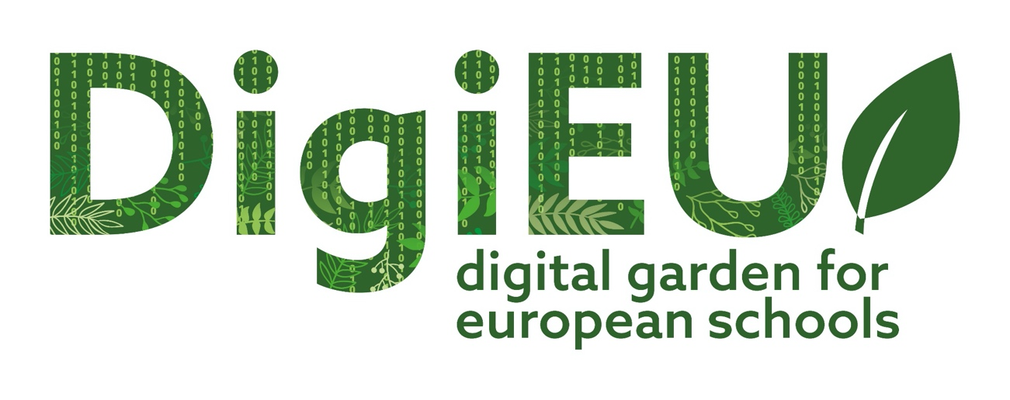

4th NEWSLETTER

3rdTPM Erasmus+ DigiEU project took place in Cyprus
After two years since the first face-to-face meeting, all project partners were able to find the conditions to meet again face-to-face, this time in Cyprus (Paphos).

The DigiEU project faced one of the greatest challenges on a global scale, the pandemic caused by the sars covid-19 virus. Despite this, the tasks and goals were developed and met practically all the timings defined.
The pandemic crisis proved better than ever, that the educational context is changing progressively, open technology based education was implemented and the educational system practically all over the world had to adapt in a short time to a new reality - 3.0. (TEAL)
More than ever, we believe in the DigiEU project, in the advantages of the use of digital tools, gamification and interactive components and the ease with which these can be adapted to the most diverse learning contexts.
During the meeting in Paphos, the partners reviewed the pending tasks, the next steps of the project and the best strategy to ensure the realization and success of all project points.

WELCOME TO THE FOURTH NEWSLETTER OF THE DigiEU PROJECT!

We will be happy to tell you about it:
- Some topics from the meeting held in Cyprus;
- Results of the meeting - Intellectual Outputs;
- The perspectives and next steps of the project;

The idea behind the DigiEU project is to provide more quality in teaching and learning, expand knowledge and understanding of the educational practices of the countries involved, modernization of schools, need for active student participation.

THE PROJECT MANUAL

- The project manual will consist of 5 chapters that are fundamentally structured under a theoretical underpinning and a practical underpinning.

- Chapter 1 - Introduction​
- Chapter 2- RESEARCH / CASE STUDIES​
- Chapter 3- TEAL THEORY​
- Chapter 4.1- SELF-CONSTRUCTION OF URBAN GARDENS​
- Chapter 4.2- OUTDOOR EDUCATION​
- Chapter 5 - Conclusion​

The manual will soon be just a click away on our project website please enter the link here!
www.digi-eu.eu

THE INTERNATIONAL PILOT TEST IN ROMANIA (C1)
The PILOT TESTING activity for the DigiEU project consists of two phases .
1. National PILOT TESTING: 1 in each country to test IO1 and IO2, which has already been developed in February 2021 in each of the project partner countries.
2. International Pilot test in Romania during the international C1

When?

November 17-18-19, 2021​

Who?

- 25 teachers (Science, Biology, Math, Computer Science, Designers, Farmers, Nutritionists)
- 50 students;
- 4 counselors;

How?
The international pilot test will consist of two parts a theoretical and pratical one where participants will have to opportunity, hosted by Liceul Theoretic Marin Preda in Turnu Magurele, to test the project and involve students, disseminate knowledge about the project and involve students and teachers to collect comments and feedback on the Expert Toolkit and the Game app-Digital Garden that will help the partnership to fine-tune the project results for their final version.

Follow us on Facebook and our website… soon we will have more updates on the Training in Romania!

HOW CAN YOU FIND US?
Facebook.com/DigitalGardenEU
www.digi-eu.eu

PROJECT PARTNERS
The project is developed by five partners from five
different EU countries:

Project number :2019-1-IT02-KA201-062276

